**with statement in Python**

In Python, **with statement** is used in exception handling to make the code cleaner and much more readable. It simplifies the management of common resources like file streams. Observe the following code example on how the use of with statement makes code cleaner.

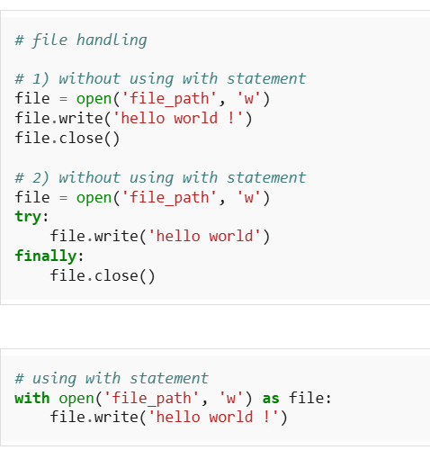

Notice that unlike the first two implementations, there is no need to call file.close() when using with statement. The with statement itself ensures proper acquisition and release of resources. An exception during the file.write() call in the first implementation can prevent the file from closing properly which may introduce several bugs in the code, i.e. many changes in files do not go into effect until the file is properly closed. The second approach in the above example takes care of all the exceptions but using the with statement makes the code compact and much more readable. Thus, with statement helps avoiding bugs and leaks by ensuring that a resource is properly released when the code using the resource is completely executed. The with statement is popularly used with file streams, as shown above and with Locks, sockets, subprocesses and telnets etc.